**Project Overview**

These are the list of features that is available on the starter project for this app. You will need to have a good understanding of all these features to be able to do the simulation.

**List Screen**

**[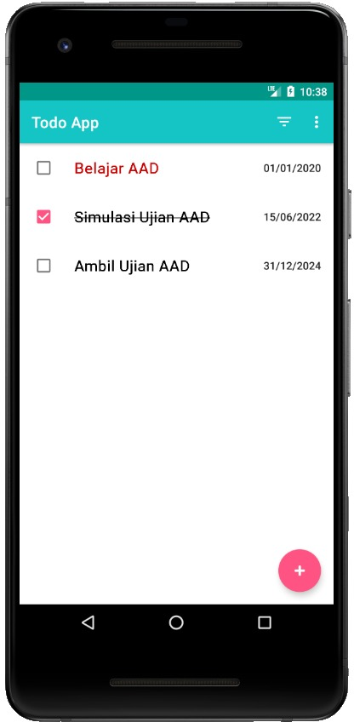](https://www.dicoding.com/academies/287/tutorials/14557)**

* Option Menu :
  + Filter tasks by all, active, or completed.
  + Navigate to the Settings screen.
* Floating Action Button (FAB) :
  + android.R.drawable.ic_input_add
* List item :
  + Checkbox (R.id.item_checkbox)
  + TaskTitleView (R.id.item_tv_title)
    - TextAppearance : MaterialComponents.Headline6
    - MaxLines  :1
  + TextView (R.id.item_tv_description)
    - TextAppearance : MaterialComponents.Subtitle2

**Add Task Screen  
[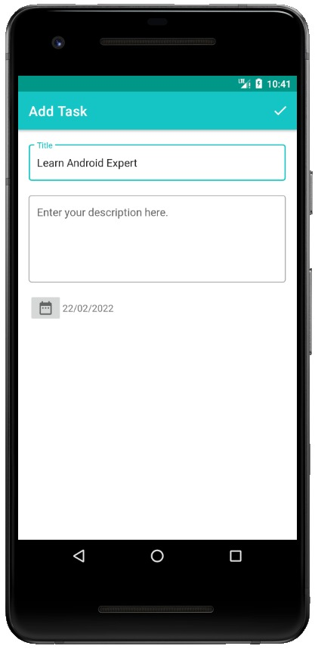](https://www.dicoding.com/academies/287/tutorials/14557)**

* Option Menu:
  + Save task
* Input :
  + TextInputEditText (R.id.add_ed_title)
    - MaxLines : 1
  + TextInputEditText (R.id.add_ed_description)
    - MaxLines : 5
  + ImageButton
    - onClick : showDatePicker
    - src : @drawabale/ic_date

**Detail Task Screen  
[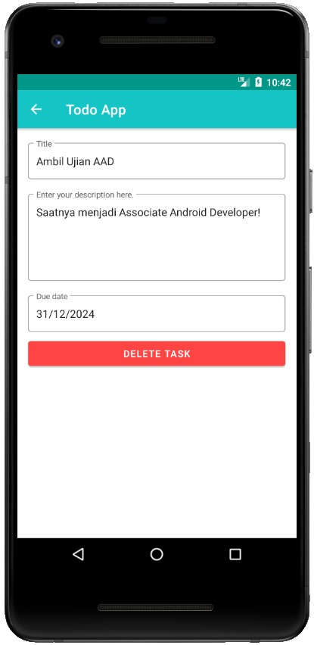](https://www.dicoding.com/academies/287/tutorials/14557)**

* Show Data :
  + TextInputEditText (R.id.detail_ed_title)
    - MaxLines : 1
    - Focusable : false
  + TextInputEditText (R.id.detail_ed_description)
    - MaxLines : 5
    - Focusable : false
  + TextInputEditText (R.id.detail_ed_due_date)
    - Focusable : false
  + Button (R.id.btn_delete_task)
    - backgroundTint: @android:color/holo_red_light
* Up Navigation Button :
  + Navigates to List Screen

**Settings Screen**

**[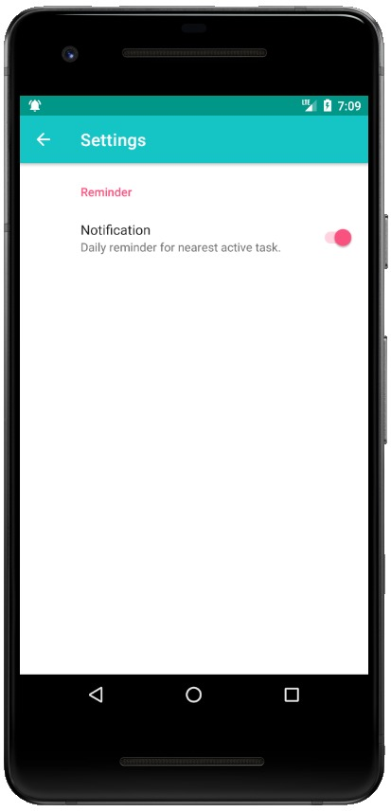](https://www.dicoding.com/academies/287/tutorials/14557)**

* Setting Preference:
  + Reminder Notification
    - Toggle setting to enable or disable daily reminder notification.
* Up Navigation Button :
  + Navigates to List Screen

**Notification**

[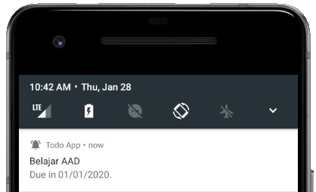](https://www.dicoding.com/academies/287/tutorials/14557)

* Small icon : R.drawable.ic_notification
* Content title : Nearest Active Task Title
* Content text : R.string.notify_content with Nearest Active Task Due Date

**Code Submission**

Complete the tasks below. You can download the starter project here:  
[Starter Project To-Do App](https://www.dropbox.com/s/3a5k21an0amn3il/Todo%20App.zip?dl=1)

1. Define a local database table and DAO (data access object) based on schema in **app/schemas/tasks.json**. Use FilterUtils#geFilteredQuery to create a filterable query.
2. Initiate RecyclerView with TaskAdapter and update database when onCheckChange.
3. Display title in list-item based on state using TitleTextView (CustomView).
4. Show a detailed task when the list is selected and implement a delete action.
5. Create AddTaskViewModel class to insert a new "task" into the database.
6. Schedule and cancel daily reminder using WorkManager. If notification preference is on, get the nearest active task from the repository and show notification with pending intent.
7. Address the following comment from the QA team:  
   SnackBar does not show when the task completed/activated.
8. Write UI test to validate when user tap **Add Task (+)**, the AddTaskActivity displayed.

If your submission does not match the required criteria, it will be rejected by our Academy Code Reviewers. Below are some items that you will need to avoid:

* The initial data list from local JSON does not appear.
* Filter menu not working properly.
* The state of the TitleTextView does not match.
* Failed to add new data.
* Failed to delete data, either from the detail page or by swiping the list.
* Data is not updated and SnackBar does not appear when the checkbox is checked.
* Reminder notifications cannot be displayed on Oreo devices and above.
* UI testing failed or not according to the scenario.
* Having a Zip file in the Zip file that you submitted (multiple layers of zip files).
* Force closed application.
* The project cannot be built.
* Submit files other than the Android Studio project.
* Submitting projects that are not your own work.
* Delete or code in starter project/base code. (example: change GridLayout to LinearLayout).

Prepare your submission for this simulation as below,

* Use Android Studio.
* Submit your work as an archived Android Studio Project (ZIP) folder

Before submitting the project, make sure that you have properly exported it. See steps below to properly export the project:

* Select the menu **File → Manage IDE Settings → Export to ZIP File ...** in Android Studio.
* Select a storage directory and click **OK**.
* Using the method above, the ZIP file size will be smaller compared to using manual compression through the file explorer.

**Exit Interview**

Record yourself and answer each of the questions below.  
You are only allowed to use a maximum of 2 minutes for each question.  
The purpose of this interview is to see how well you understand the exam project:

1. What project have you worked about?
2. Which part is hardest?
3. What components have been used to show a list of tasks?
4. How does notification reminder work?
5. Why do we need a Custom View?

If your submission does not match the required criteria, it will be rejected by our Academy Code Reviewers. Below are some items that you will need to avoid:

* Audio is missing or cannot be heard clearly.
* The video quality is bad and the resolution is too small.
* Incomplete or incorrect answers.

Prepare your submission for this exit interview simulation as below,

* Answers must be in English.
* 2 minutes maximum for each question.
* Use a clear voice (make sure no other sounds are recorded).
* Upload to your preferred sharing platform (we recommend Google Drive).

Make sure the video link that you submit**can be accessed** by other people. For example, if you use Google Drive, right-click on the video file → Get Link → Change the permissions from "Restricted" to "Anyone with the link" → Copy Link → Paste in the submission note provided.